Version 1.0
07/12/2019

Alan DUFFIN
X00159409
cERTIFICATE, CLOUD SOLUTIONS ARCHITECTURE 2019, PROJECT

Implementation Phase 3.2

Table of Contents

PROJECT PLAN FOR ITERATION 3 3
PROJECT PROGRESS 4
WORKFLOW / FRONTEND INTEGRATION AND TOKEN PERSISTENCE 5
FRONT END ENHANCEMENTS 8
STEP FUNCTIONS AND CLOUDFORMATION 10
NEXT TASKS 12
REFERENCE LIST AND BIBLIOGRAPHY 13

PROJECT PLAN FOR ITERATION 3.2

The table below (Table A) lists the tasks that I planned to complete for the final implementation deadline.

Project Phase | Service / Area | Implementation Task
Build / Development | AWS Step Functions | Extend the Step Function Workflow state machine to support Underwriting Clarification requests to the Broker.
Build / Development | AWS Lambda | Develop 4 new Lambda functions to support the clarification use cases. These include functions to support CRUD operations and functions for notifications and pause / restart the Step Function workflow.
Build / Development | AWS Angular | Implement new Front end screens to support the clarifications use case.
Build / Development | AWS Cloudformation | Integrate the deployment of the Workflow state machine into the project Cloud formation template.
Test | AWS Step Functions | Test State Transitions / Events / Human interaction
Table A.

PROJECT PROGRESS
This week I completed the following tasks:

- Extend the Step Function Workflow state machine to support Underwriting Clarification requests to the Broker.
- Develop 4 new Lambda functions to support the clarification use cases. These include functions to support CRUD operations and functions for notifications and pause / restart the Step Function workflow.
- Implement new Front end screens to support the clarifications use case.
- I have tested all new state Transitions / Events / Human interaction

Please review the video (MP4) demostrating the final version of this project at the following URL:
https://s3-eu-west-1.amazonaws.com/appd.cloud.project/IT-Tallaght-Mortgage-Workflow-WebApp-2019-12-08.mp4

Due to time constraints I was unable to refactor the Cloudformation Serverless Application Model template to integrate the Step Function deployment. The current iteration of the CloudFormation tempate includes the packaging and deployment of the following AWS components:

  - WebSocket API Gateway Resources
  - HTTP Restful API Gateway Resources
  - DynamoDB Tables: Mortgages, Customers, Step Function Tokens, Clarifications, WebSocket connections, ID generation.
  - Lambda Websocket Functions
  - Lambda Mortgage / Customer / Clarification CRUD Functions
  - Lambda Step Functions Support Functions
  - Lambda SNS Functions
  - SNS Topics
  - SES Endpoints

STEP FUNCTIONS – clarifications - FINAL VERSION

The final version of my Step Function workflow is shown in Figure AWS.STEP.1. In the past week it have been enhanced to include the branches that allow clarifications between the humans involved in the Mortgage applicatoin process. It allows an unlimited number of question / response clarifications to happen between the Underwriter and the Broker to provide a clear understanding of the financial / personal circumastances of the applicants.

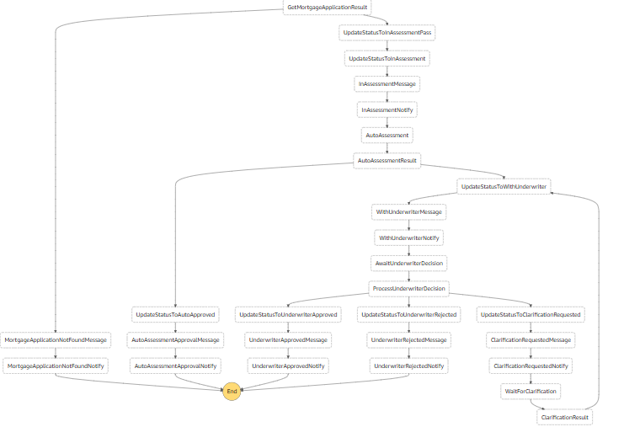
AWS.STEP.1

lambda functions - clarifications

In order to suppor the enhancements to the Workflow that allow Underwriters approve / reject / clarify mortgage applications from the Browser based front end a number of additional Lambda functions are required.

The following Lambda Functions have been added :
  - Mortgages-Stack-BrokerClarificationPOSTFunction
  - Mortgages-Stack-CreateNotificationMessageFunction
  - Mortgages-Stack-AddClarificationFunction
  - Mortgages-Stack-BrokerClarificationPOSTFunction
  - Mortgages-Stack-DeleteClarificationFunction
  - Mortgages-Stack-GetClarificationsFunction
  - Mortgages-Stack-WaitForBrokerClarificationFunction

Example Code.
Source Code on Git Hub: https://github.com/GeneralYeager/tallaght.mortgages

ClarificationDB.js ; Utility Function.

'use strict';

const AWS = require('aws-sdk');
const ddb = new AWS.DynamoDB.DocumentClient({ apiVersion: '2012-08-10' });
const { CLARIFICATION_TABLE_NAME } = process.env;

exports.queryClarifications = async function (mortgageId) {

try {
var clarificationParams = {
TableName : CLARIFICATION_TABLE_NAME,
KeyConditionExpression: "mortgageId = :mortId",
ExpressionAttributeValues: {
":mortId": mortgageId
}
};

let clarifications = await ddb.query(clarificationParams).promise();
return clarifications;
} catch (error) {
console.log(error);
return null;
}
};

exports.addClarification = async function (mortgageId, currMessageId, text) {

try {
var newMessage = {
TableName: CLARIFICATION_TABLE_NAME,
Item: {
"mortgageId": mortgageId,
"messageId": currMessageId + 1,
"text": text
}
};
const result = await ddb.put(newMessage).promise();
return result;
} catch (error) {
return null;
}
};

exports.deleteClarifications = async function (clarification) {
try {
var params = {
TableName: CLARIFICATION_TABLE_NAME,
Key: {
'mortgageId' : clarification.mortgageId,
'messageId' : clarification.messageId
}
};
const deleteResult = await ddb.delete(params).promise();
return deleteResult;
} catch (error) {
return null;
}
};

FRONT END CLARIFICATIONs
I have enhanced the front end Angular code to allow brokers and underwriters to interact via a new real time clarification process.

The new screenflow is shown in the Screen shots below.

The Broker submits a Mortgage application for Decision. Figure ANGULAR.1.
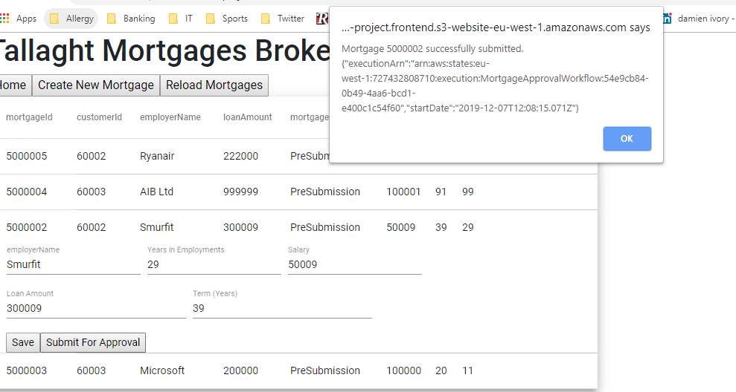
Figure ANGULAR.1.

The Underwriter recieves a notification of the requirement to approve or reject the mortgage application if the application was not automatically passed by the Auto Assessment rules. Figure ANGULAR.2
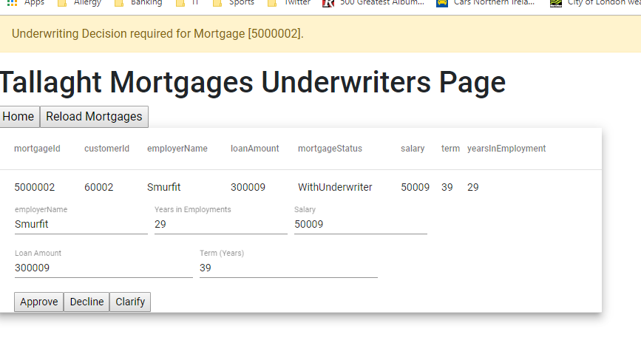
Figure ANGULAR.2.

The Underwriter can input a question or request if they require clarification or action by the Broker that is dealing with the applicants. Figure Angular.3
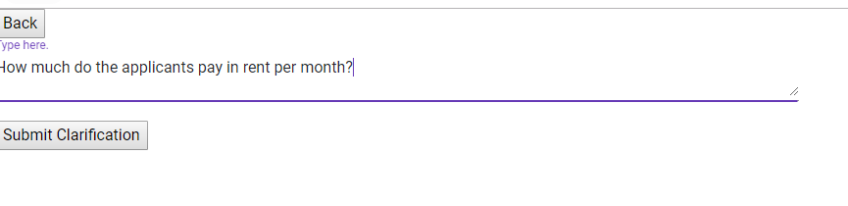
Figure Angular.3

The Broker will receive notification that the Underwriter has changed the status of the application to 'ClarificationRequested' and that the need to respond or take action regarding documentation. FIGURE ANGULAR.4
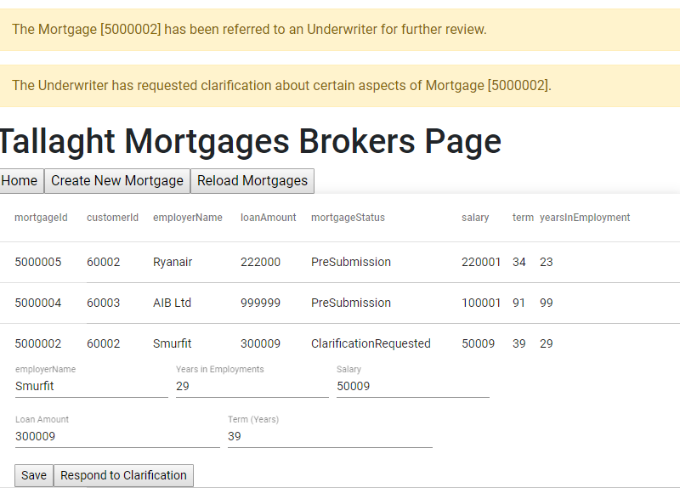
FIGURE ANGULAR.4

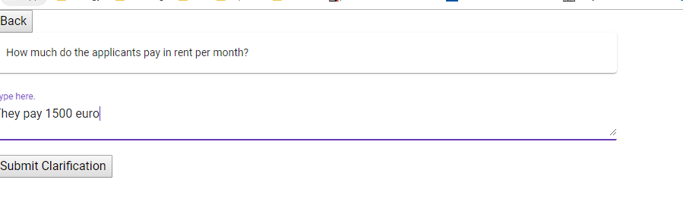
FIGURE ANGULAR.5

Once the Broker has completed the Clarification task and resubmitted the mortgage application the Workflow returns the control to the Underwriter for further clarifications or final assessment. FIGURE ANGULAR.6
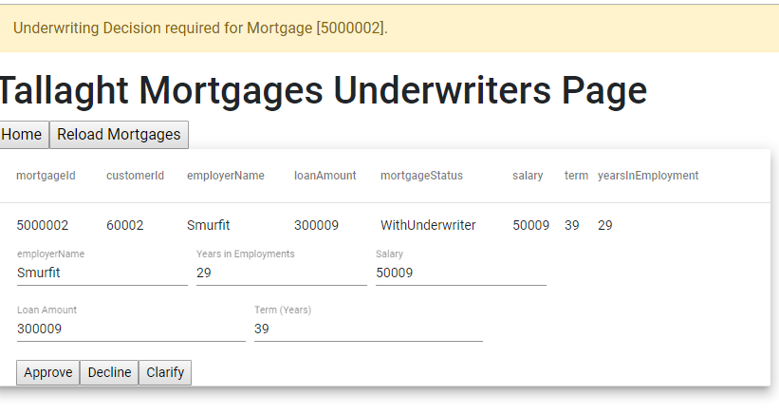
FIGURE ANGULAR.6

The Underwriter can view the Broker feedback. FIGURE ANGULAR.7
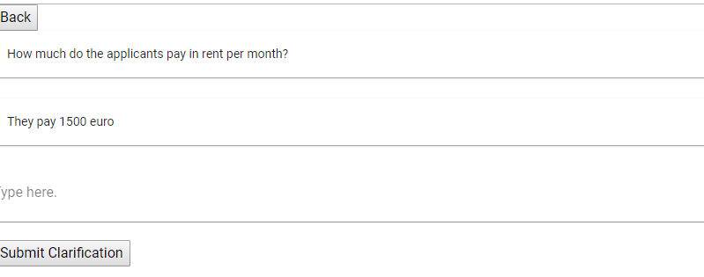
FIGURE ANGULAR.7

In this case the Underwriter has received clarification about the applicant rental payments and decides to Approve the application. FIGURE ANGULAR.8
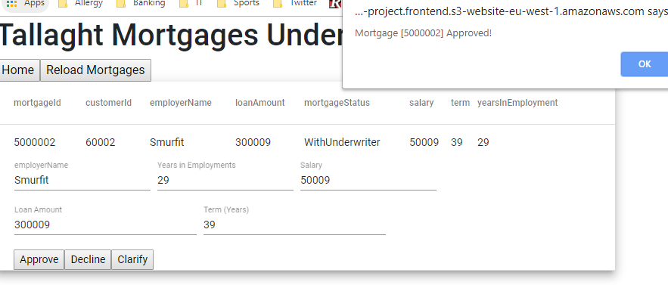
FIGURE ANGULAR.8

Finally the Broker recieves a notification that the Mortgage Application has been Approved. FIGURE ANGULAR.9
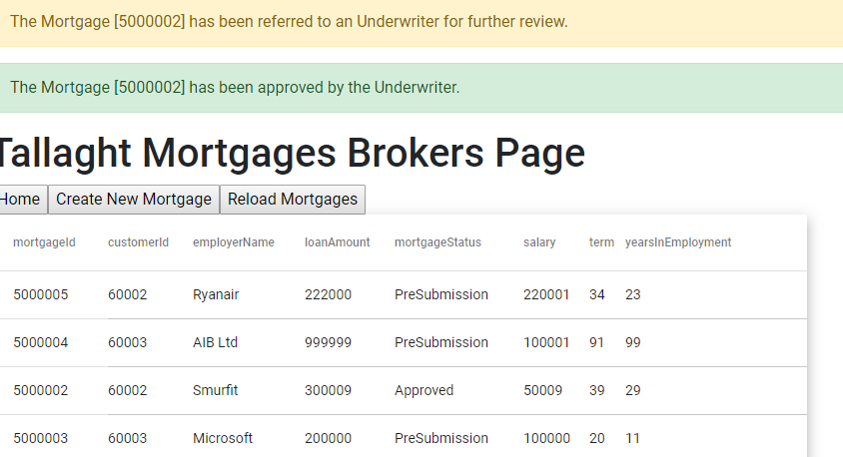
FIGURE ANGULAR.9

REFERENCE LIST AND BIBLIOGRAPHY

[1] AWS Free Tier. https://aws.amazon.com/free/
[2] AWS CLI. https://docs.aws.amazon.com/cli/latest/userguide/install-windows.html
[3] AWS CLI SAM. https://docs.aws.amazon.com/serverless-application-model/latest/developerguide/serverless-sam-cli-install-windows.html
[4] Node JS. https://nodejs.org/en/download/
[5] Configure AWS CLI. https://docs.aws.amazon.com/cli/latest/userguide/cli-chap-configure.html
[6] Visual Studio Code. https://code.visualstudio.com/download
[7] Configure AWS on Visual Studio Code. https://docs.aws.amazon.com/toolkit-for-vscode/latest/userguide/setup-toolkit.html
[8] Install Docker Toolbox. https://docs.docker.com/toolbox/toolbox_install_windows/
[9] DynamoDB Cloudformation Template. https://github.com/GeneralYeager/tallaght.mortgages/blob/master/mortgage.dynamo/dynamo-create.yml
[10] Lambda Cloudformation Template. https://github.com/GeneralYeager/tallaght.mortgages/blob/master/tud.mortgages/Tallaght-Mortgages-App/template.yaml
[11] Step Function State Machine Template. https://github.com/GeneralYeager/tallaght.mortgages/blob/master/mortgage.workflow/StateMachineV3.txt
[12] https://aws.amazon.com/blogs/compute/announcing-websocket-apis-in-amazon-api-gateway/
[13] https://docs.aws.amazon.com/step-functions/latest/dg/concepts-amazon-states-language.html
[14] https://docs.aws.amazon.com/step-functions/latest/dg/concepts-input-output-filtering.html
[15] https://docs.aws.amazon.com/step-functions/latest/dg/welcome.html
[16] https://docs.aws.amazon.com/step-functions/latest/dg/connect-to-resource.html#connect-wait-token

